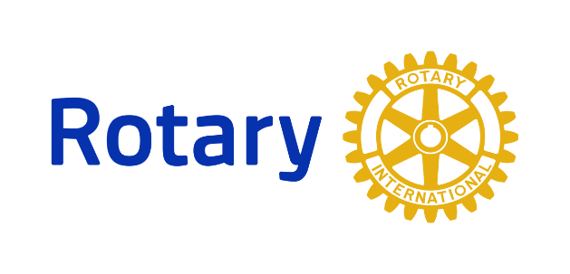

District 7255 Rotaract

What is a Rotaract Club? Rotaract Clubs bring together people ages 18 and older to exchange ideas with leaders in the community, develop leadership and professional skills, and have fun through service. Rotary and Rotaract members work side by side to take action through service. Rotary club sponsors offer guidance and support and work with Rotaract Clubs as partners in service.
How do I join a current Rotaract Club or start a new one?
Contact Rotary District 7255 Rotaract Chair Warren Sternberg – warrensternberg1@gmail.com

